ITECH3208 - Project 1:



# Fednews Webpage Upgrades

Alexander Langdon - 30297113

Kevin Garcia - 30315566

Ben James - 30331986

Michael Dickenson - 30331949

Sunil Kumar -30311976

**Project Handbook**

05 MAY 2019

# Documentation Log

|  |  |  |  |
| --- | --- | --- | --- |
| **Version Number** | **Date Approved** | **Approved By** | **Descrition** |
| **1.1** | 04/04/2019 | Project Team | Document Outlay & Design |
| **1.2** | 01/05/2019 | Project Team | Finalize Document Draft |
| **1.3** | 04/05/2019 | Project Team | Publishing Document |
| **1.4** | 05/05/2019 | Project Leader | Ready For Submission |

# 

# Preface

This project handbook has been created to act as a support/reference guide for project developers, site maintainers, and possibly users of the future Fed News webpage. The documentation displayed within the handbook provides a detailed understanding of how and why segments of this project will be designed and constructed, and contains an overview of how the Fed News project team will use common Information Technology Design and Development processes and methodologies to to create the best solution for our client.

# 

# Table of Contents

**Fednews Webpage Upgrades** **0**

**Documentation Log** **1**

**Preface** **1**

**Table of Contents** **3**

**1. Preliminaries and document Management** **5**

1.1 Project Summary 5

1.2 Project Objective: 5

1.3 Project Deliverables 5

Table 1.2.1 Deliverables and description 6

1.4 Evolution of the Handbook 6

1.5 Reference Materials 7

1.6 Definitions and Acronyms 7

Table 1.5.1 Definitions and Acronyms Table 7

**2. Organization and Processes** **8**

2.1 Process Model 8

Table 2.1 .1 Sprint cycles and elaborations 8

2.2 Assets Breakdown structure 9

2.2 Organizational or team Structure 10

Table 2.2 .1 Roles and Description 10

Figure 2.2.1 Scrum Flow 11

2.3 Organization Boundaries and Interfaces 13

2.3.1 Client Interface 13

2.4 Project Responsibilities 13

Table 2.4 .1 Responsibility chart 13

**3. Managerial Process** **14**

3.1.1 Management Objectives 14

3.1.2 Priorities 14

Table 3.1.2.1 Priorities and description 14

3.2 Assumptions, Dependencies and Constraints 16

3.2.1 Assumptions 16

3.2.2 Dependencies table 16

3.2.3 Constraints 16

**4. Technical or Managerial Process** **17**

4.1.1 Methods 17

4.1.2 Tools 18

Table 4.1.2.1 Tools and Description Table 18

4.2 Software Documentation 20

**5. Non-functional Requirements** **20**

5.1 Platform 20

5.2 Communications 21

5.3 Performance 21

5.4 Security and Privacy 21

5.5 Audience, Usability and Accessibility 21

5.6 Reliability 22

5.7 Modifiability 22

5.8 Economic 22

5.9 Legal 22

5.10 Standards 22

**6. Software and Systems Architecture** **23**

6.1 Architecture Objectives 23

6.2 High-Level Architecture 23

Figure 6.2.1: Article Submission, Review Process 24

Figure 6.2.2: Non_Registered User Access 25

6.3 Website Structure 25

Figure 6.3.1: Sitemap flow 26

6.4.1 Styles and Visual Design 27

Figure 6.4.1: Fed News Home Screen Revamped Wireframe 27

Figure 6.4.2: Staff News Revamped Wireframe 28

Figure 6.4.3: Submitting a News Item Wireframe 29

6.5 Colour & Fonts 30

# 

# 1. Preliminaries and document Management

## 1.1 Project Summary

The Federation University website requires an upgrade under the ‘FedNews’ webpage. The purpose of this project is to improve functionality and features within the ‘FedNews’ webpage and to overcome any defects from the initial installment. Although improvements are to be made certain features/functions need to be kept such as access for staff to create a news article and have it published on the webpage, news items are summarised in a daily email and emergency notification system should be part of the solution. The resources needed to upgrade the website are simple coding applications that supports PHP coding, HTML or even Javascript which are easily accessible via Laptop or Computer. The main objective is to create a webpage for creating,reading,updating and deleting news items while assuring conveniency, attractiveness and user friendly experience.

## 1.2 Project Objective:

Main aim or objective of our project is as follows:

* Update the Federation university fed news page
* Add new functionality and Features within the page of Fednews

## 1.3 Project Deliverables

The completion of this project will be concluded by delivering PHP, Javascript or HTML files to the client to be installed if satisfied. The project team will present the client with operational updated web pages which will contain a more appealing user interaction system.

There will be no user documentation or technical documentation submitted with this product. The product is installed and hosted by the client.

### Table 1.2.1 Deliverables and description

|  |  |
| --- | --- |
| **Deliverables** | **Description** |
| **PHP files** | a scripting language that is often used to develop a variety of web pages and Internet applications.These files are processed by a remote server and are then returned to the user's Web browser as plain HTML. |
| **Javascript files** | an object scripting language which is used in web pages along with markup language HTML. JavaScript is adopted universally by web browsers for its dynamic content to be executed in a webpage. |
| **CSS files** | Cascading style sheets are used to format the layout of Web pages. |
| **HTML files** | HTML is a HyperText Markup Language file format used as the basis of a web page. HTML is a fileextension used interchangeably with HTM. HTML is consists of tags surrounded by angle brackets. The HTML tags can be used to define headings, paragraphs, lists, links, quotes, and interactive forms. |

## 1.4 Evolution of the Handbook

The Project Handbook act as a guideline of information throughout the project schedule. The handbook is accessible by the members of the development team via Google drive (as it is created using google docs). This provides the team a way of managing documentation, processes and procedures of developing the new web pages.

The team has agreed to divide and conquer the handbook into different parts while still contributing information and experience when help is needed from team members. This will allow us to extract members potential and knowledge to further understand our individual skill.

Updates to the Handbook will be discussed through team meetings. Since we will be performing as an agile development team.The Scrum Master will inform the project team of any updates via the Announcements channel on Discord. Any changes will be reviewed by the team’s concept artist while being consulted by the developers. At the end of the sprint cycle, the team will finalize and sign off the handbook.

## 1.5 Reference Materials

(Howe and Teufel, 2014).Native Advertising and Digital Natives: The Effects of Age and Advertisement Format on News Website Credibility Judgments.4(1). [Accessed by 12/4/2019].

## 1.6 Definitions and Acronyms

### Table 1.5.1 Definitions and Acronyms Table

|  |  |
| --- | --- |
| Term | Definition |
| **Agile development** | The Agile Method is a particular approach to project management that is utilized in software development. |
| **AJAX** | Asynchronous JavaScript And XML is a web programming technique in JavaScript that enables a portion(s) of a web page to be reloaded from the server without the whole page being reloaded |
| **CSS** | Cascading style sheet  While HTML defines the structure of the content on a webpage css define the style |
| **HTML** | This programming language is the building block of websites. |
| **HTTP** | Hypertext Transfer Protocol (Secure) is a secured version of HTTP used by many websites handling personal information |
| **JavaScript** | A programming language used to add dynamic functionality to static (HTML) webpages. |
| **PHP** | PHP is a general-purpose programming language originally designed for web development. |
| **RSS Feed** | RSS (Really Simple Syndication) feed allows users to subscribe to news updates . |
| **Discord** | First tool for the communication between the team members. |
| **End User** | The user of the website including students, staff or non university member. |
| **SMART** | Specific, Measurable, Achievable, Relevant and Time-Related |
| **DB** | Database management system |

# 2. Organization and Processes

## 2.1 Process Model

The project will undergo multiple sprints in order to fulfill the success criteria. Each sprint will justify a milestone that will ensure the team is on a convenient track to success. The project process model is process and events that are driven by the architecture of the product.

The success criteria is developed with goals; the team and the client discussed over. When the team accomplishes each goal, only then preparation of delivering the product to the client can be executed.

### Table 2.1 .1 Sprint cycles and elaborations

|  |  |  |
| --- | --- | --- |
| **Sprint** | **Activities** | **Timeline** |
| Sprint 1 | * Create Product Handbook | 01/04/2019 - 07/04/2019 |
| * Exploration of XAMPP and WAMP * Exploration of RSS feeds * Analyze the original web-page for bugs and test * Justifying the project’s main functionality and features * Mapping the flow of the whole system and New Design layouts | 08/04/2019 - 20/04/2019 |
| Sprint 2 | * Creating Wire Frames | 22/04/2019 - 27/04/2019 |
| * Exploration of PHP, HTML,Javascript and CSS * Exploration of Docker * Exploration of Tech Stack | 28/04/2019 - 03/05/2019 |
| * Creating functional web pages with HTML and Javascript | 06/05/2019 - 30/05/2019 |
| Sprint 3 | * Applying basic PHP functionalities * Creating Internal database * Creating Server with WAMP * Testing PHP files through XAMPP | 29/07/2019 - 20/08/2019 |
| Sprint 4 | * Completion of full functionality of all the web pages * Implement designs ( Themes and Color Schemes) * Finalizing login functions | 23//08/2019 -  25/09/2019 |
| Sprint 5 | * Run through testers * Revisions * Implementation new functionalities * Fixing of any new bugs | 30/09/2019 - 25/10/2019 |

## 2.2 Assets Breakdown structure

To be aligned with the project approach, the following is the high level work breakdown structure

**Phase 1: Scope and plan**

* Requirement analysis
* Project management plan
* Site map
* Determine required resources

**Phase 2: Design and the style**

* Wireframes and design elements
* Mockups

**Phase 3 : Develop and test**

* Build development framework
* Appropriate test plan

**Phase 4 : Deploy and monitor**

* Polishing

**Phase 5 closure**

* Client fulfillment
* Closing of project

## 2.2 Organizational or team Structure

The project team consist of five members. The team members are allocated with different positional roles for executing this project.

### Table 2.2 .1 Roles and Description

|  |  |  |
| --- | --- | --- |
| Name | Role | Description |
| Aaron Maskell | Client | Provide us the feedback and keep informed the progress update. |
| Grant Meredith | Supervisor | Helping in the Project Development,Providing the feedback on the work done. |
| Kevin Garcia | Product Owner | The scrum master is the team role responsible for ensuring the team lives agile values and principles and follows the processes and practices that the team agreed they would use. |
| Sunil kumar | Scrum Master | Checking the work and making sure team is on track and changes are documented as per the requirements. |
| Michael Dickenson  Alexander Langdon  Benjamin James | Team Member | Attends and actively participate in the team meetings.  Performs the provided tasks  Communicate on the Issues related to teams. |

## Figure 2.2.1 Scrum Flow

2.4 Interfaces Organisation Boundaries

## 2.3 Organization Boundaries and Interfaces

### 2.3.1 Client Interface

The client liaison is the product owner. The product owner is Kevin Garcia. The product owner is responsible for managing and maintaining communication between the project team and the client. The means of communication occurs via outlook email. Email discussions between the product owner and client are carbon-copied to team members for reference. The product owner will be responsible for all the information being transmitted throughout the team. This will determine the goals set for the team.

Sunil kumar is the Scrum master who is actively responsible for the all actions undertaken between the team and communication being held within the team and for the meetings and phases. Documentation will be provided by sunil kumar and other active team members which needs to be done within the provided phases and time period appropriately.Any problem faced by team members need to be resolved by fellow member.

if again the problem is not solved the team product owner or scrum master may consult with a supervisor to clear any clarification. Communication will be done through discord application , google docs ,verbal communication and scheduled meetings.

## 2.4 Project Responsibilities

### Table 2.4 .1 Responsibility chart

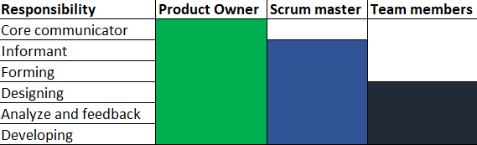

# 3. Managerial Process

## 3.1.1 Management Objectives

The Project team tasked with an obligation to upgrade and improve the functionality of the Federation University’s News web page. This objective will enable all members associated with this project, an opportunity to equip their skills. The team will be using an agile methodology as guidance to accomplish the project goals and to manage objectives throughout the management.

After running the team through the five stages of Tuckman’s team development rule, we hope to perform with more unity. The team goal is to perform with freedom of pointing out errors and accepting constructive feedbacks to pursue our obligation of improving the web page. The team shall divide and conquer major tasks, thus, we can match each task to member’s skill sets.

A managed team with good flow of communication will allow us to perform efficiently and effectively. This will give us more room to focus on the user experience, design layout, web page functionality and new conceptual upgrades.

## 3.1.2 Priorities

### Table 3.1.2.1 Priorities and description

|  |  |  |
| --- | --- | --- |
| Objectives | Level of Priority | Description |
| Initiate team development | Medium | Facilitate better communication, motivates team members, develops problem solving skills, and promotes creativity which in turn will increase productivity. |
| Familiarise team with objectives | High | A better understanding of our goals and priorities will give the team some sort of urgency when performing the work. |
| Create a product backlog | High | The project backlog will be the first set of information to give the team an idea of the goals of this project.The concepts created in this document will be based on requirements discussed with the client. |
| Creating tasks’ timeline | Medium | Creating a scheduled timeline for each task should provide members with a sense of initiatives to commence project tasks. |
| Predict priority shift | Low | Frequent changes in priority will result from a project scope change, which directly impacts on both quality and schedule. Communicating the severity of the impact through the product owner, scrum master and team members will be crucial to maintaining the project’s quality. Good management of priorities will be essential for management to understand the impact of the changing priorities on the team. |
| Differentiate urgent and important tasks | Low | Urgent tasks are tasks that have to be dealt with immediately. Important tasks are tasks that contribute to long-term missions and goals. When we classify the project tasks into these categories, a clearer path of productivity will be created. |
| Success criteria based on client’s requirements | High | The team needs to make sure the project outcomes is satisfactory for the client |
| Team performance is consistent and punctual | Medium | The team needs to consistently be productive and o time to complete this project with quality. This can be tracked by hitting milestones throughout the project. |
| Updating client with any new developments | Medium | Any new and informative development should be run through the client to ensure the client requirements are still intact. |

## 3.2 Assumptions, Dependencies and Constraints

### 3.2.1 Assumptions

* The team will have the same end goal at the end of this project.
* The team will consist of the same members, client and supervisor throughout the project.
* The team will not need to be invest money to achieve the project’s optimal quality.
* Team members are qualified and have the skill sets to complete tasks within the project.
* The project preparation stage will take one semester (12 weeks) and another semester (12 weeks) to create the actual product.
* The project goals are set to satisfy the client’s requirements
* The team will be running with an agile methodology

### 3.2.2 Dependencies table

|  |  |
| --- | --- |
| Internal Dependencies | External Dependencies |
| Regular discussion with client to assure the team is on the right track | The team should be able to understand the coding language recommended by programs to attaining our goals |
| Consistent line of communications throughout the team to keep productivity going. | Users (testers) should be able to use this easily with comprehensive instructions to guide them. |
| Team members need to utilize their skill sets and help one another | The free programs, the project will be worked on will provide us the full range of its functionality to complete our task. |

### 3.2.3 Constraints

* The website is strictly created for the Federation University IT Department
* The project is set to follow instructions and criterias provided to us by the Project 1(ITECH 3208) and Project 2(ITECH 3209) courses.
* The project will create features and functionality that was requested by the client
* The project will have no funding sources. Investment will be limited by the team members.
* The web pages theme will follow the professionalism of the original website

# 4. Technical or Managerial Process

## 4.1.1 Methods

Managerial Process: Tuckman’s 5 Stages

This process of learning to work together effectively is known as team development. Research has shown that teams go through definitive stages during development. Bruce Tuckman, an educational psychologist, identified a five-stage development process that most teams follow to become high performing. He called the stages: forming, storming, norming, performing, and adjourning. Team progress through the stages is shown in the following diagram.

* **Forming** - a team takes time, and members often go through recognizable stages as they change from being a collection of strangers to a united group with common goals.
* **Storming** - people start to push against the boundaries established in the forming stage. This is the stage where many teams fail. Storming often starts where there is a conflict between team members' natural working styles.
* **Norming** - The entire team is now unified around a specific goal.
* **Performing** - The team reaches the performing stage, when hard work leads, without friction, to the achievement of the team's goal.
* **Adjourning** - group wraps up its work and then dissolves. At this time, it is important for members of the team to get appropriate closure as well as recognition for the work they accomplished.

Technical Process: Scrum Methodology

Scrum is a framework that helps teams work together.Scrum is an agile project management methodology or framework used primarily for software development projects with the goal of delivering new software capability every 2-4 weeks.The Scrum methodology is defined by team roles, events (ceremonies), artifacts, and rules. Scrum will lead to:

* Higher productivity
* Better-quality products
* Reduced time to market
* Improved stakeholder satisfaction
* Better team dynamics

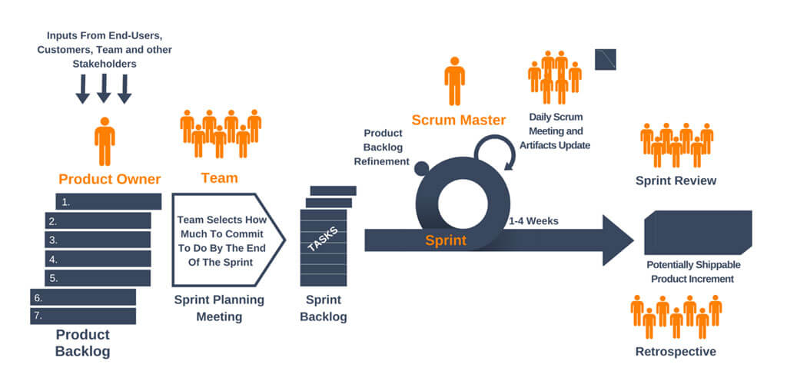

## 4.1.2 Tools

### Table 4.1.2.1 Tools and Description Table

|  |  |  |
| --- | --- | --- |
| **Tools** | **Description and Details** | **Purpose** |
| **Discord** | Discord is a proprietary freeware VoIP application and digital distribution platform designed for video gaming communities, that specializes in text, image, video and audio communication between users in a chat channel. Discord runs on Windows, macOS, Android, iOS, Linux, and in web browsers. | Communication |
| **Google Drive** | Google Drive is a file storage and synchronization service developed by Google. Google Drive allows users to store files on their servers, synchronize files across devices, and share files. | Documentation management |
| **Lucid Chart** | Lucidchart is your solution for visual communication and cross-platform collaboration. Create professional flowcharts, process maps, UML models. | Design Creation |
| **Microsoft Office** | Microsoft Office is a family of client software, server software, and services developed by Microsoft. | Documentation management |
| **Facebook Messenger** | Facebook Messenger is a messaging app and platform. Originally developed as Facebook | Communication |
| **Snapchat** | Snapchat is a multimedia messaging app used globally | Communication |
| **Pencil software** | Pencil is a vector drawing program for Windows that lets you make your own digital comics. Pencil is based around traditional hand-drawn animation techniques, and it's free. At the center of the application is a timeline, which allows you to add four types of layers: bitmap image, vector image, sound, and camera. | Design creation |
| **Snipping Tool** | Snipping Tool is a Microsoft Windows screenshot utility included in Windows Vista and later. It can take still screenshots of an open window, rectangular areas, a free-form area, or the entire screen. Snips can then be annotated using a mouse or a tablet, stored as an image file or an MHTML file, or e-mailed. | Additional tools |
| **NotePad ++** | Notepad++ is a text editor and source code editor for use with Microsoft Windows. It supports tabbed editing, which allows working with multiple open files in a single window. The project's name comes from the C increment operator. Notepad++ is distributed as free software | Code development |
| **XAMPP** | XAMPP is a free and open-source cross-platform web server solution stack package developed by Apache Friends, consisting mainly of the Apache HTTP Server, MariaDB database, and interpreters for scripts written in the PHP and Perl programming languages.XAMPP only offers MySQL (Database Server) & Apache (Web Server) in one setup and you can manage them with the xampp starter | Database management |
| **WAMP** | WampServer refers to a software stack for the Microsoft Windows operating system, created by Romain Bourdon and consisting of the Apache web server, OpenSSL for SSL support, MySQL database and PHP programming language | Server management |
| **Atom** | Atom is a free and open-source text and source code editor for macOS, Linux, and Microsoft Windows with support for plugins written in Node.js, and embedded Git Control, developed by GitHub. Atom is a desktop application built using web technologies. | Code development |
| **Visual Studio** | Microsoft Visual Studio is an integrated development environment from Microsoft. It is used to develop computer programs, as well as websites, web apps, web services and mobile apps. | Design creation |
| **Invisionapp** | InVisionapp is basically a prototyping tool that allows you to create clickable versions of your design.  It really works in early stages of your projects, when you have still mockups, or to create MVP to test or to present to customers. | Design interaction |
| **GitHub** | GitHub is a web-based hosting service for version control using Git. It is mostly used for computer code. It offers all of the distributed version control and source code management functionality of Git as well as adding its own features | Design creation and code development |
| **GIMP** | GIMP is a free and open-source raster graphics editor used for image retouching and editing, free-form drawing, converting between different image formats, and more specialized tasks. GIMP is released under GPLv3+ licenses and is available for Linux, macOS, and Microsoft Windows. | Design creation |

### 

## 4.2 Software Documentation

All documentation is maintained by all project members to provide a full outlining on all areas of sprint life cycles, developed areas and any other modifications. The idea of documenting all information from all members is to give greater understanding from all perspectives throughout the design and development stages of the FedNews project.

# 5. Non-functional Requirements

## 5.1 Platform

The Platform is the important factor to be considered, while the development of the webpage we are considering that the platform used by anyone can use the latest version of all the popular browsers and the program will be tested within the reasonably current versions of the following browsers:

* Firefox
* Chrome
* Edge
* Android Chrome
* Safari

The server files will run within a Docker container. The following technologies will be used.

* The MySQL will be used for the DB.
* PHP For any server-side scripting.
* HTML, JS and CSS for any browser code and layout of the the website.

These requirements can be changed, but will serve as the standard guidelines.

## 5.2 Communications

The software will be standalone, but easily modifiable to integrate with the FedUni authentication system. All other requirements should also be self-contained.

## 5.3 Performance

The website should not have any noticeable amount of lag. This is important, and will be largely depend on optimising the code when we see an issue.

## 5.4 Security and Privacy

All user inputs will be sanitised, especially those which are db-related.

All passwords will be hashed on the client side, not sent as plain text over the internet.

## 5.5 Audience, Usability and Accessibility

The site needs to meet the WCAG2AA standards.

* Aria standards

## 5.6 Reliability

The site should have the ability to create alerts for ITS outages, and should be otherwise stable and accessible across browsers to the degree the underlying server is.

## 5.7 Modifiability

There are no given modifiability requirements for this project, but the project will be delivered in the form of source code files, and those will be entirely modifiable by the client and anybody they have work on that code.

To enhance this, the code will be written in HTML, CSS, PHP and Javascript, which are some of the most wide-spread programming languages. This will enhance the modifiability of the code.

## 5.8 Economic

This project will be done completely free of cost (not any cost )for or even including any kind of resource gathered to create it. Things that that will be included are writing of software code or webpage code, even the logos for the feduni web page. It is to be consider that no cost will be incurred by the project team in order to complete it.

## 5.9 Legal

The all the rules and regulations will be comply the main rules and standards of the fed uni website and actions taken under the fed news webpage will strictly follow university rules and law and even the educational institutional law will be considered.

## 5.10 Standards

Fednews will meet the standards of the federation university website and the institutional standards and specifically mentioned by the client that it should meet the university standard so this will be taken into consideration.

# 6. Software and Systems Architecture

## 6.1 Architecture Objectives

The System Architecture for the Fed-News Website will be updated to introduce new functionality and improve upon the existing system where possible. An improvement in Navigation efficiency will increase ease of use. Security for private articles through blocking students from viewing the staffs RSS Feed. All registered users will be able to submit news articles, that will be reviewed by an Admin User. Improvements to the administrator review system for new articles has been improved, in turn reducing inappropriate content. Introduce the ability to comment, like, and share articles. Users will be kept up to date with the latest news relevant to that user, and users will be alerted to relevant emergency news items.

## 6.2 High-Level Architecture

The websites Architecture has been designed to revolve around the user, giving the user a more personal experience based on user type. The systems design has been improved to provide users with both popular and relevant news and alert them to emergency news items.

The websites most basic functions can be accessed by any user, when delving deeper into its functionality the actions allowed are reliant on User Type. Student Users can view all news accept Staff Articles and are restricted from viewing staff RSS Feed. Staff Users cannot review or remove articles and Comments, but like all users can report on inappropriate content. All registered users can submit new Articles to any area of study or campus location, and create events, these are all reviewed by Admin Users. Admin Users can use the website like any other user, but also review new articles before potential publication and can remove any inappropriate content.

### Figure 6.2.1: Article Submission, Review Process

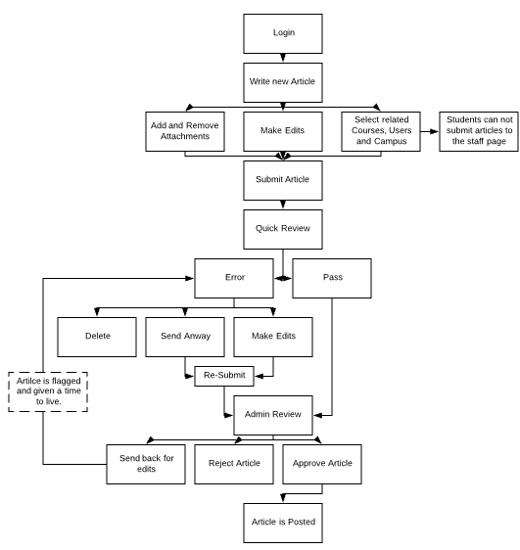

When creating an article, users can add and remove attachments and select relevant filters to help targeted users view the article. On submission the article is checked for any errors and inappropriate language. If found the user is prompted to make edits or submit anyway flagging the article for the Administrators. Admins receive and review the articles, they can then ask for edits to be made to the article, reject it, or approve and publish it to the site. The User is then notified of the verdict, if edits are needed the user must make them and re-submit within the week, or the document will be automatically rejected.

PHP Scripting will be used for many server side functions to be present in the website, such as email notifications and alerts, the sharing of articles through social media. The main use of PHP will be for storing and abstracting the articles from the database and verifying user login credentials with the Federation University Staff and Student registry.

### Figure 6.2.2: Non_Registered User Access

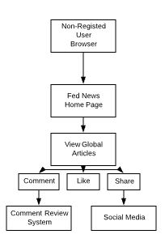

## 6.3 Website Structure

The overall design of the website has been structured to give users a simple and efficient experience. Meaning the websites design doesn’t try to over complicate structure and allows users to navigate the website with ease. As the sitemap in 6.3.1 shows, each of the main pages are accessible from the home page. Then dependent on the user type (Student, Staff, Administrator or non-Registered User) they will be able to access these pages.

### Figure 6.3.1: Sitemap flow

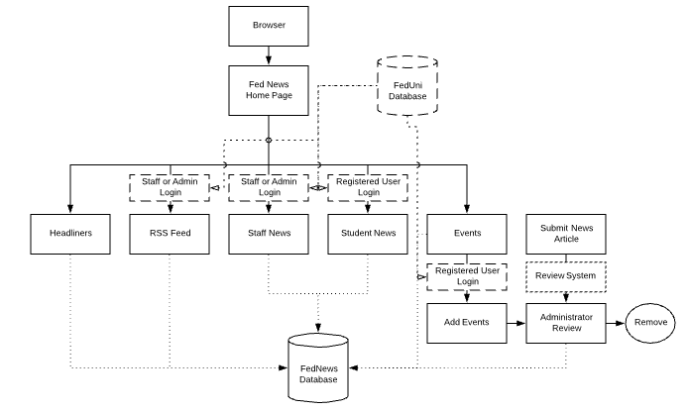

## 6.4.1 Styles and Visual Design

### Figure 6.4.1: Fed News Home Screen Revamped Wireframe

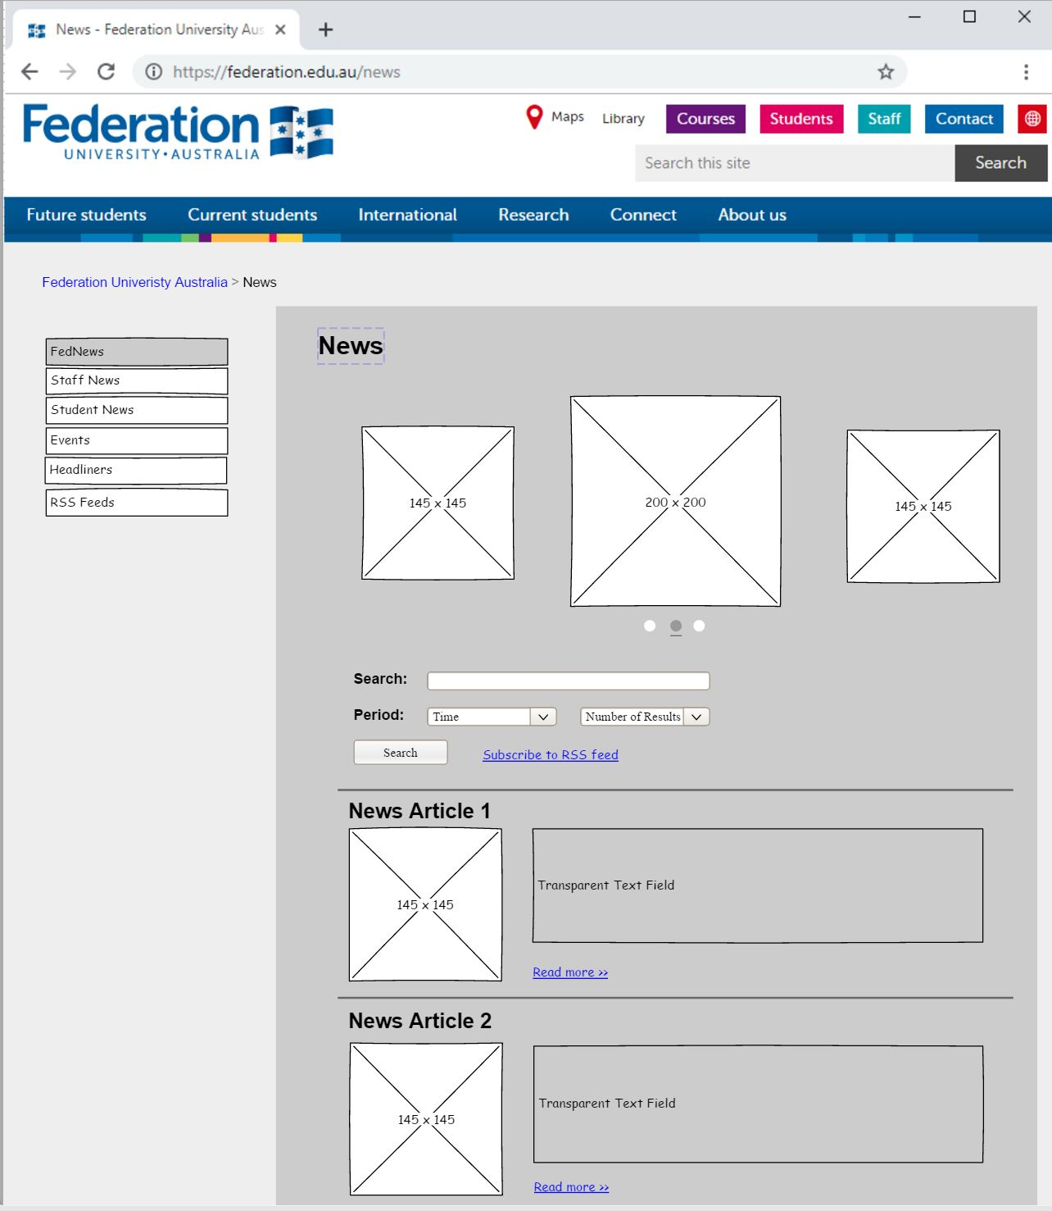

### Figure 6.4.2: Staff News Revamped Wireframe

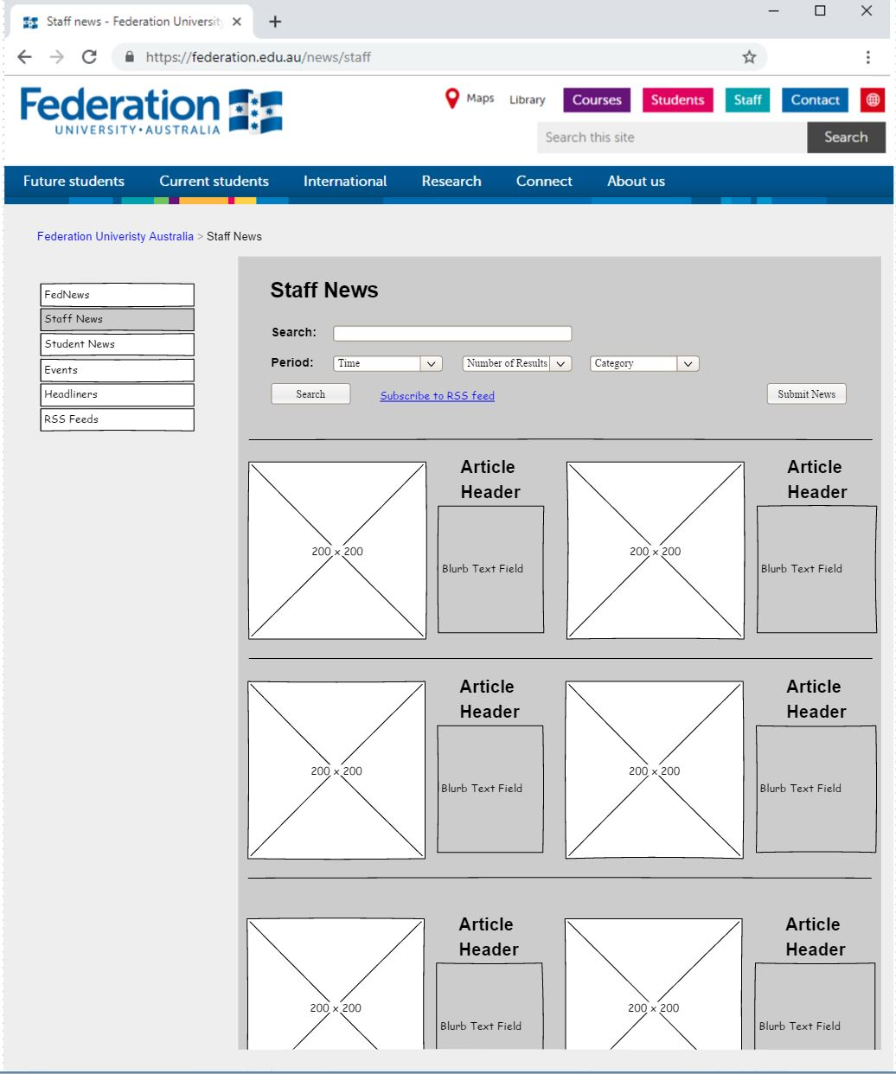

### Figure 6.4.3: Submitting a News Item Wireframe

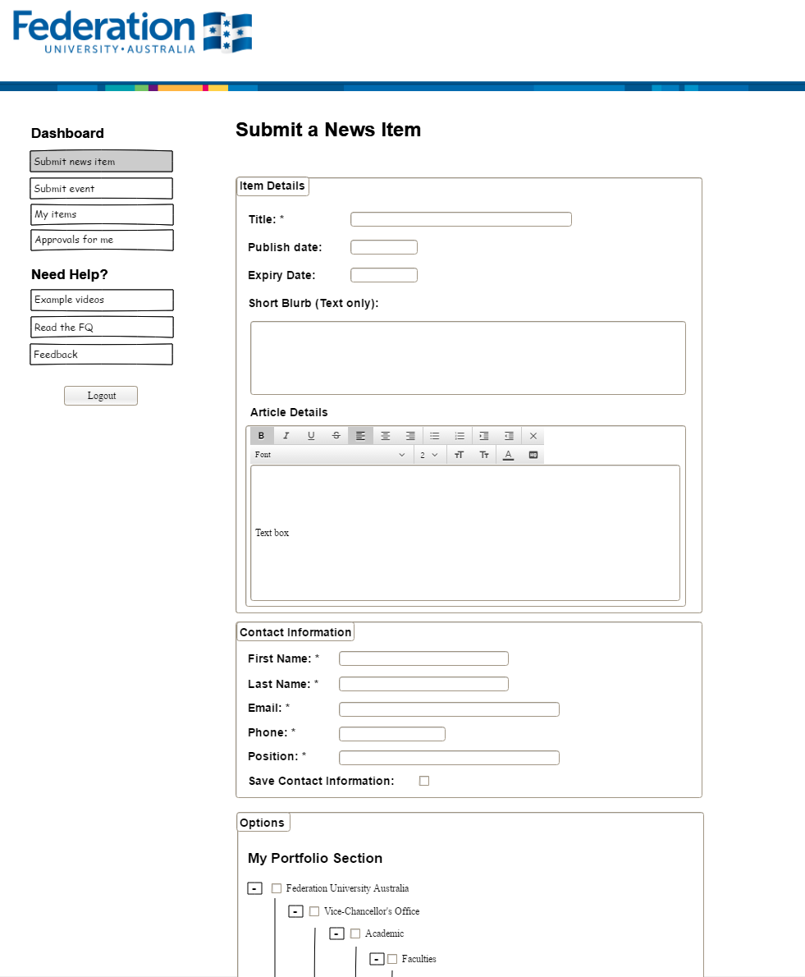

The figures above are three wireframes which were designed, to display changes which could potentially be implemented in the project. These wireframes include the Federation University header and colour scheme to allow the consistency of the universal webpage to flow.

## 6.5 Colour & Fonts

Colour scheme for background and foregrounds design of the webpage are already implemented throughout the website as seen in the image above. These colours are able to identify to the user that the webpage they’re viewing is apart of the Federation University Site as just by identifying the unique design and colour scheme architecture. The colour scheme for web page architecture is important, hence the use of the Federations University colour scheme implementing blue as the main colour target. The effects of blue can make the audience to feel more productive, stability and calm.

Fonts are also a very important part of the webpage systems design, as certain sections of the webpage are more important than others, hence why designs have focal points. The use of unique h1, h2, p... structures are to allow for the website to use many fonts consistently throughout the webpage architecture and design. Shape, size and types of fonts have a similar impact as the colour scheme does on the audience.

### 

# 